DAY 2 PRACTICE TASKS ON PUBLIC IP vs PRIVATE IP ADDRESSING
✅ TASK 1 — PRIVATE IP ADDRESS IDENTIFICATION
📌 Task Name
Private IP Address Identification using IPConfig

🎯 Objective
To identify the system’s private IPv4 address, subnet mask, and default gateway.

🛠 Steps Performed
Step 1: Opened Command Prompt.
Step 2 Executed command: ipconfig
Step 3
Observed:
- IPv4 Address
- Subnet Mask
- Default Gateway
Output/Screenshot
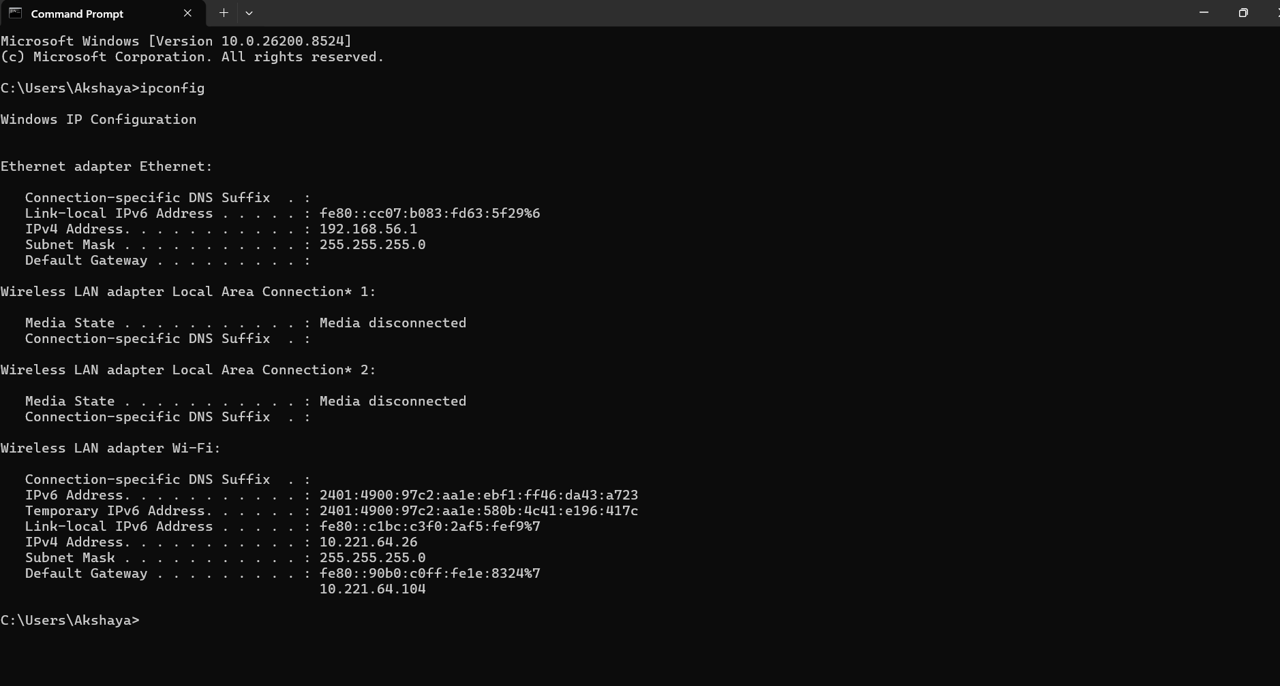

📊 Result
Successfully identified the local/private IPv4 address and network configuration details.

🧠 Learning Outcome
Learned how internal devices are identified inside a private network.

🔐 Important Notes for IAM Analysts
IAM systems use private IP information to:
- Identify trusted internal devices
- Monitor internal network access
- Apply internal access policies

✅ TASK 2 — PUBLIC IP ADDRESS IDENTIFICATION
📌 Task Name
Public IP Address Identification

🎯 Objective
To identify the internet-visible public IP address assigned by ISP.

🛠 Steps Performed
Step 1
Opened web browser.
Step 2
Searched:
What is my IP
Step 3
Observed:
- Public IP
- ISP Name
- Region
Output/Screenshot
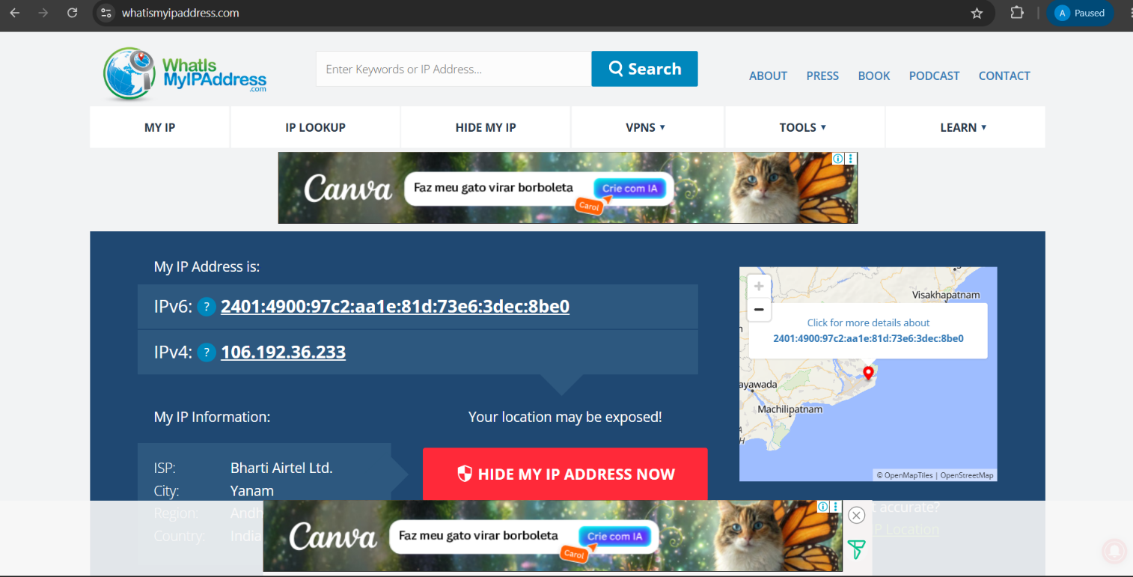
📊 Result
Successfully identified public internet-facing IP address.

🧠 Learning Outcome
Learned difference between internet-visible and internal IP communication.

🔐 Important Notes for IAM Analysts
Public IPs are monitored for:
- Geo-location analysis
- Risk-based authentication
- Suspicious login detection

✅ TASK 3 — PRIVATE IP RANGE ANALYSIS
📌 Task Name
Private IP Range Verification

🎯 Objective
To verify which RFC1918 private IP range the system belongs to.

🛠 Steps Performed
Step 1
Observed IPv4 address from ipconfig.
Step 2
Compared with private ranges:
10.x.x.x
172.16.x.x – 172.31.x.x
192.168.x.x
Step 3
Documented IP class.
Output/Screenshot
📊 Result
Successfully identified private IP category and address range.

🧠 Learning Outcome
Learned classification of enterprise private networks.

🔐 Important Notes for IAM Analysts
Organizations use private IP ranges to:
- Segment departments
- Restrict internal access
- Secure enterprise communication

✅ TASK 4 — INTERNET CONNECTIVITY TEST
📌 Task Name
Internet Connectivity Testing using Ping

🎯 Objective
To test communication between local machine and internet server.

🛠 Steps Performed
Step 1
Opened Command Prompt.
Step 2
Executed:
ping google.com
Step 3
Observed:
- Packet replies
- Response time
- Packet loss
Output/Screenshot
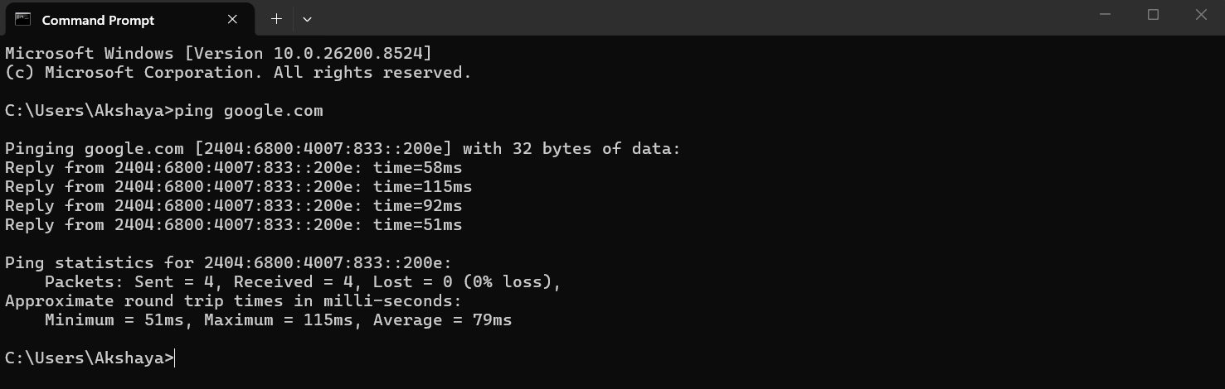

📊 Result
Successfully verified internet connectivity.

🧠 Learning Outcome
Learned how systems verify external communication.

🔐 Important Notes for IAM Analysts
Ping testing helps IAM/security teams:
- Verify VPN connectivity
- Troubleshoot access issues
- Detect communication failures

✅ TASK 5 — PUBLIC IP CONNECTIVITY TEST
📌 Task Name
Direct Public IP Connectivity Test

🎯 Objective
To verify internet connectivity using direct public IP communication.

🛠 Steps Performed
Step 1
Opened Command Prompt.
Step 2
Executed:
ping 8.8.8.8
Step 3
Observed:
- Packet transmission
- Internet reachability
Output/Screenshot
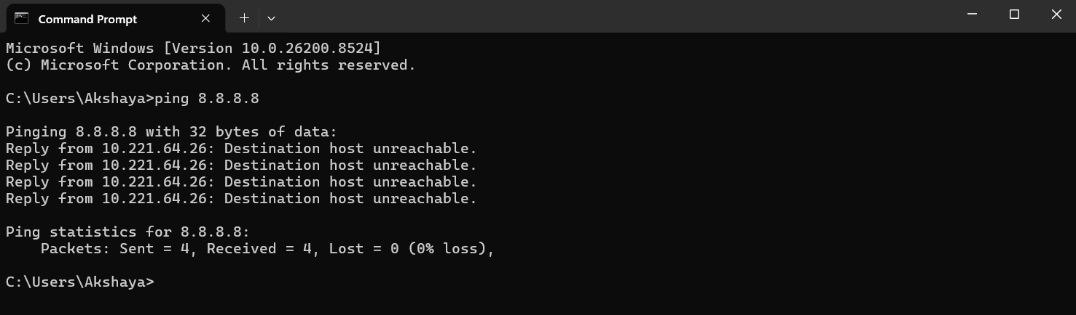

📊 Result
Successfully verified direct communication with external public server.

🧠 Learning Outcome
Learned difference between DNS-related and direct IP communication.

🔐 Important Notes for IAM Analysts
Helps identify:
- DNS failures
- Routing issues
- Firewall restrictions

✅ TASK 6 — DNS RESOLUTION ANALYSIS
📌 Task Name
DNS Lookup Analysis using NSLookup

🎯 Objective
To analyze how DNS converts domain names into IP addresses.

🛠 Steps Performed
Step 1
Opened Command Prompt.
Step 2
Executed:
nslookup google.com
Step 3
Observed:
- DNS server
- Resolved IP addresses
Output/Screenshot
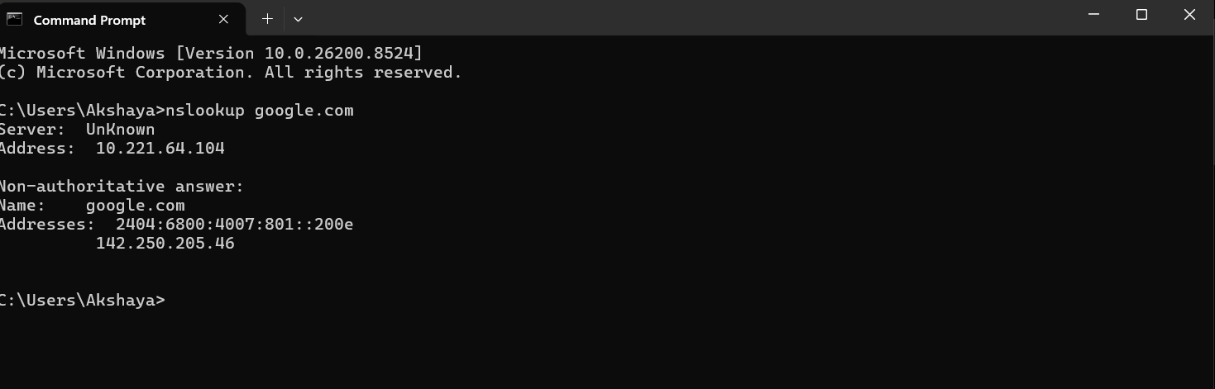

📊 Result
Successfully resolved domain into IP addresses.

🧠 Learning Outcome
Learned DNS communication and internet name resolution.

🔐 Important Notes for IAM Analysts
IAM systems rely on secure DNS communication for:
- Authentication services
- Cloud access
- Identity federation

✅ TASK 7 — NETWORK ROUTE ANALYSIS
📌 Task Name
Network Route Tracing using TraceRoute

🎯 Objective
To analyze how packets travel across networks.
🛠 Steps Performed
Step 1
Opened Command Prompt.
Step 2
Executed:
tracert google.com
Step 3
Observed:
- Routers
- Hops
- Packet route
Output/Screenshot
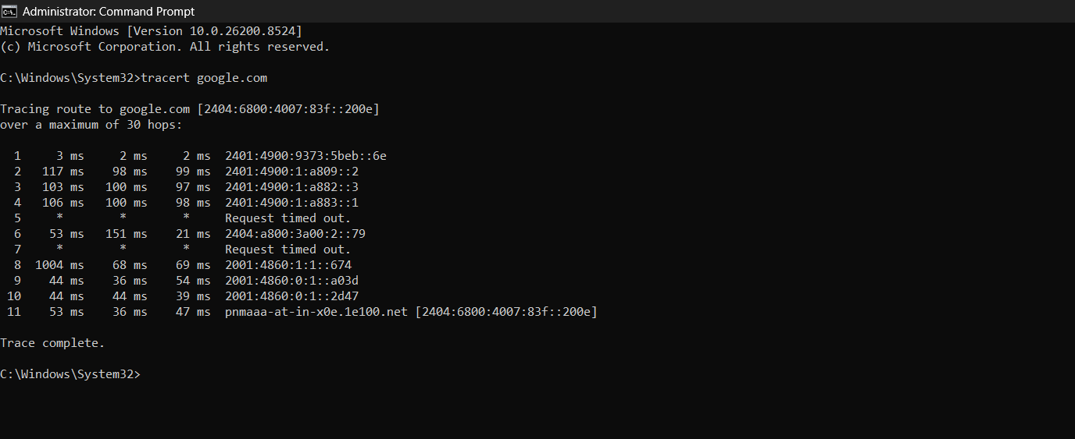
📊 Result
Successfully traced internet communication path.

🧠 Learning Outcome
Learned packet routing process and network traversal.

🔐 Important Notes for IAM Analysts
Used for:
- Troubleshooting authentication delays
- Network diagnostics
- Security investigations

✅ TASK 8 — ACTIVE NETWORK CONNECTION ANALYSIS
📌 Task Name
Network Session Analysis using NetStat

🎯 Objective
To view active TCP/IP network sessions.

🛠 Steps Performed
Step 1
Opened Command Prompt.
Step 2
Executed:
netstat
Step 3
Observed:
- Active connections
- Ports
- Listening services
Output/Screenshot
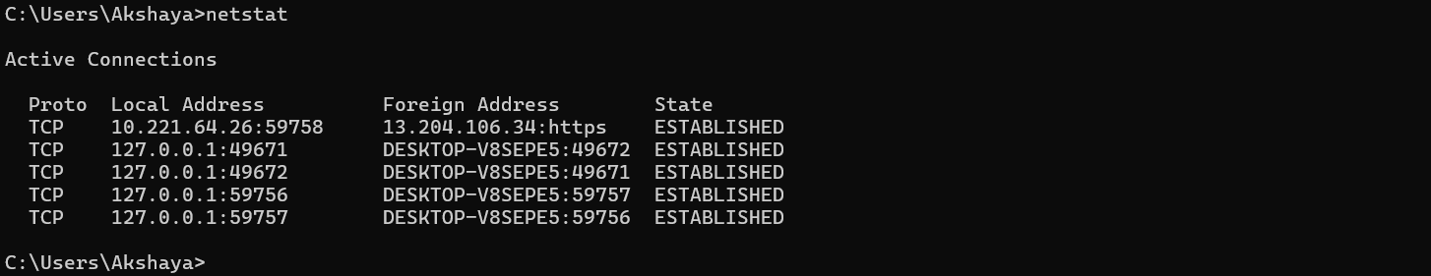

📊 Result
Successfully identified active network communication sessions.

🧠 Learning Outcome
Learned how systems maintain network sessions.

🔐 Important Notes for IAM Analysts
Helps monitor:
- Unauthorized connections
- Suspicious ports
- Malicious communication

✅ TASK 9 — PUBLIC IP GEOLOCATION ANALYSIS
📌 Task Name
Public IP Geo-location Investigation

🎯 Objective
To identify geographical information associated with public IP.

🛠 Steps Performed
Step 1
Opened:
IP Lookup Tool
Step 2
Entered public IP.
Step 3
Observed:
- Country
- Region
- ISP
Output/Screenshot
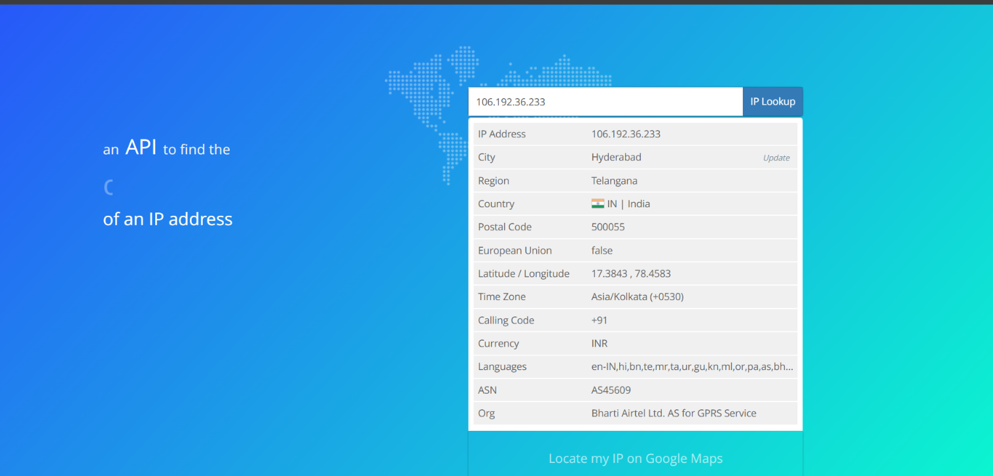

📊 Result
Successfully identified geographical information linked to public IP.

🧠 Learning Outcome
Learned how organizations detect suspicious login locations.

🔐 Important Notes for IAM Analysts
Geo-location analysis helps:
- Detect impossible travel
- Trigger MFA
- Block risky logins

✅ TASK 10 — NAT COMMUNICATION FLOW ANALYSIS
📌 Task Name
NAT Flow Architecture Analysis

🎯 Objective
To understand how routers translate private IP into public IP.

🛠 Steps Performed
Step 1
Created NAT communication diagram.
Step 2
Mapped:
Private IP → Router → NAT → Public IP
Output/Screenshot
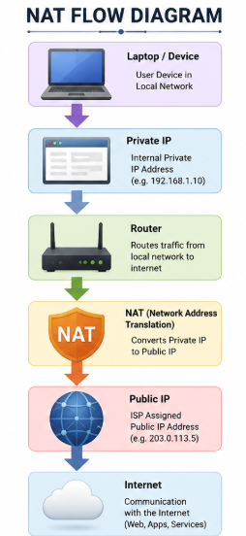

📊 Result
Successfully analyzed NAT translation process.

🧠 Learning Outcome
Learned how internet communication works through NAT.

🔐 Important Notes for IAM Analysts
NAT helps organizations:
- Hide internal networks
- Improve security
- Control internet exposure

✅ TASK 11 — IAM ACCESS CONTROL FLOW ANALYSIS
📌 Task Name
IAM IP-Based Access Control Analysis

🎯 Objective
To understand how IAM systems use IP intelligence during authentication.

🛠 Steps Performed
Step 1
Created IAM authentication flow diagram.
Step 2
Included:
IP Check
Geo-location
Risk Analysis
MFA
Conditional Access
Output/Screenshot
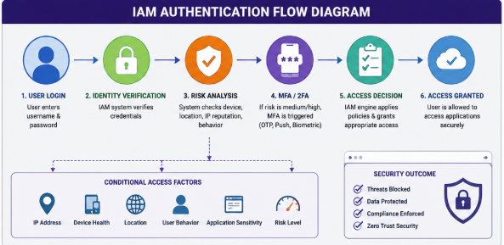

📊 Result
Successfully analyzed IP-based IAM authentication workflow.

🧠 Learning Outcome
Learned how modern IAM systems secure user access.

🔐 Important Notes for IAM Analysts
Used in:
- Microsoft Entra ID
- Okta
- AWS IAM
- Zero Trust architectures

✅ TASK 12 — FIREWALL & NETWORK SECURITY ANALYSIS
📌 Task Name
Enterprise Firewall Network Security Analysis

🎯 Objective
To understand how firewalls secure enterprise networks.

🛠 Steps Performed
Step 1
Created firewall architecture diagram.
Step 2
Mapped:
Internet → Firewall → VPN → Internal Network
Output/Screenshot
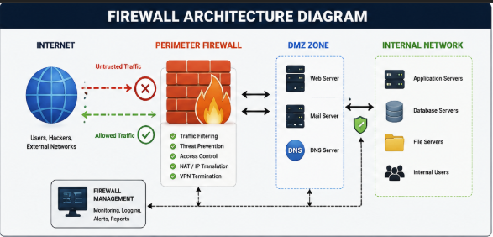

📊 Result
Successfully analyzed firewall-based network protection.

🧠 Learning Outcome
Learned how organizations secure internal infrastructure.

🔐 Important Notes for IAM Analysts
Firewalls help IAM/security teams:
- Restrict unauthorized traffic
- Protect authentication systems
- Monitor suspicious access

